Ali Hassaan Mughal Reg No : 173627

LAB 07

Task 1:

No 1:

Output

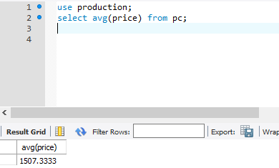

No 2:

Output

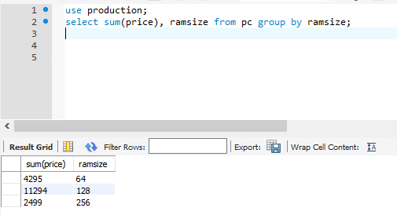

No 3:

Output

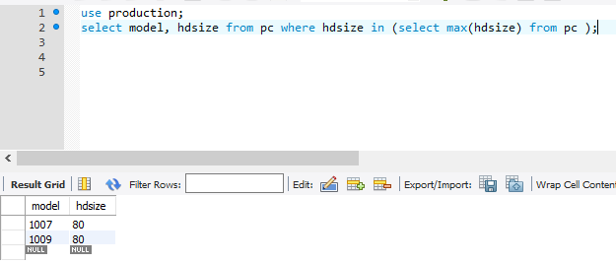

No 4:

Output

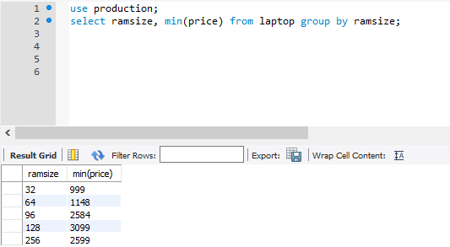

No 5:

Output

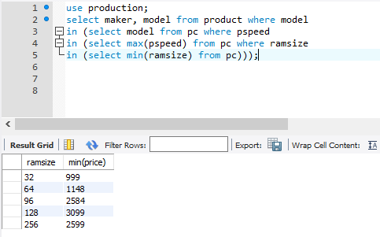

Task 2:

No1:

OUTPUT

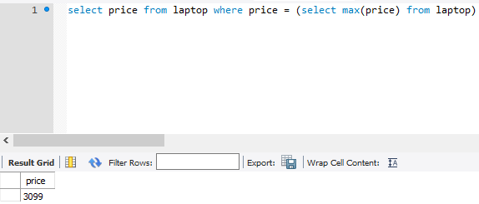

No2:

OUTPUT

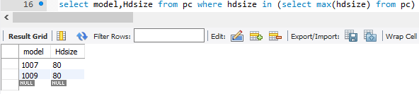

No3:

OUTPUT

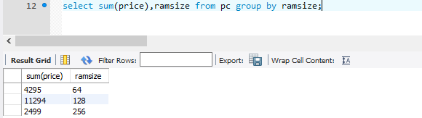

No4:

OUTPUT

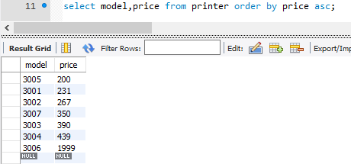

No5:

OUTPUT

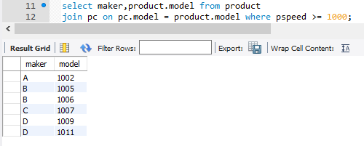

No6:

OUTPUT

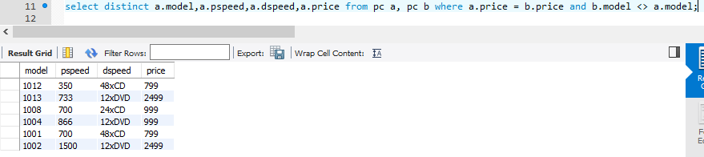

No7:

OUTPUT

